1. [SELECT](http://localhost/phpmyadmin/url.php?url=https://dev.mysql.com/doc/refman/8.0/en/select.html) nama_obat, jenis_obat as Jenis, harga

FROM `obat`

WHERE harga > 10000 ORDER BY nama_obat ASC;

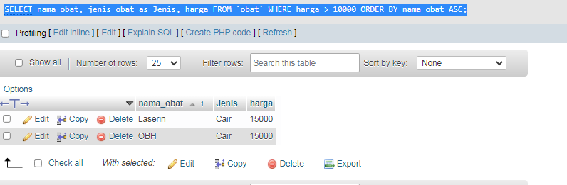

2. SELECT nama_obat, jenis_obat as Jenis, harga

FROM `obat`

WHERE harga < 10000

ORDER BY nama_obat DESC;

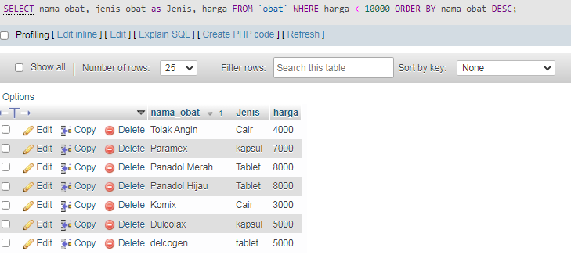

3 SELECT nama_obat, jenis_obat as 'Jenis Obat', harga

FROM `obat`

WHERE jenis_obat = 'Cair'

ORDER BY nama_obat DESC;

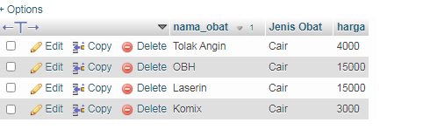

4. SELECT * FROM `pelanggan`

WHERE alamat LIKE 'ka%';

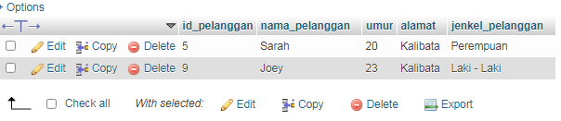

5. SELECT * FROM `obat` ORDER BY nama_obat ASC;

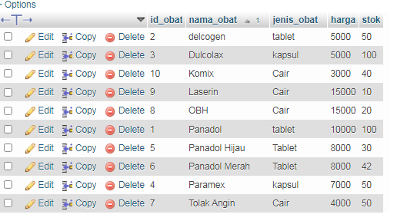

6. SELECT nama_obat, SUM(stok) as stok

FROM `obat`

GROUP BY nama_obat ASC;

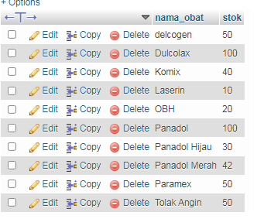

7. SELECT nama_pelanggan as nama, alamat, jenkel_pelanggan as 'Jenis Kelamin'

FROM `pelanggan`

WHERE jenkel_pelanggan = 'Laki - Laki'

GROUP BY nama_pelanggan

ORDER BY nama_pelanggan ASC;

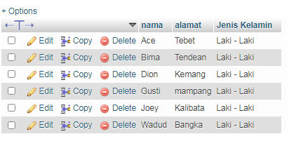

8. SELECT nama_pelanggan as nama, umur, jenkel_pelanggan as 'Jenis Kelamin'

FROM `pelanggan`

WHERE jenkel_pelanggan = 'Laki - Laki'

AND umur > 24

GROUP BY nama_pelanggan

ORDER BY nama_pelanggan ASC;

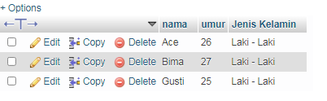

9. SELECT * FROM `penjualan`

WHERE tgl_transaksi > 2022-02-01

ORDER BY id_transaksi DESC;

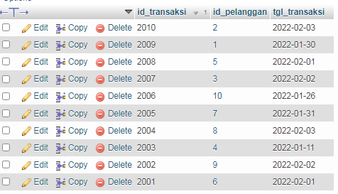

10. SELECT id_transaksi, harga_obat as harga, total_bayar as total

FROM `penjualan_detail`

WHERE total_bayar BETWEEN 15000 AND 20000;

